DIGITAL WALLET (v1.0.0) – Developers Guide

Document history

Date | Version | Description | Author
07/19/2018 | 1.0.0 | Initial version | Divyani Sharma

Contents
1. Objective 4
2. Target Audience 5
3. Architecture 6
3.1 Security 7
3.2 Versioning 11
3.3 JSON Request & Response 12
3.4 API Documentation 12
4. Custom Web Service Creation 13
4.1 Prerequisites 13
4.2 Maven POM 13
4.3 Main Application Implementation 14
4.4 Rest Controller Implementation 14
4.5 Application Properties 16
4.6 Unit Tests 18
4.7 Build Process 18
5. Deployment 19
5.1 Stand Alone Tomcat 19
5.2 Embedded Tomcat 19
6. Troubleshooting 20

Objective

This document provides detailed information about the C2i Services Framework in technical terms to allow developers to create web services that are compliant with the Digital Web Services Standard published by Enterprise Platform Services Team. This document is based on the first version (v0.5) of the C2i Services Framework.

Target Audience
This document is targeted at all Webservices Developers, including the Business Services API developers, Architects, Engineering Leads, and Security personnel, who will be contributing to any part of Enterprise Application Development in Cotiviti’s Digital organization.

Architecture
The C2i Services Framework uses Spring Framework 5.0.4 and Spring Boot 2.0.0 along with some other open source libraries as the base framework. The Framework in this phase (Phase I) concentrates on the areas of
- Security – SSO with corporate AD.
- Versioning – Enforcing the standard API versioning scheme.
- JSON Request & Response – Enforcing only JSON request and response APIs.
- API Documentation – Providing Swagger UI for documenting exposed APIs.

The Framework consists of a utility library and a Maven parent POM. The utility library is intended to help developers to create Rest services that are compliant with the standards specified in the Digital Web Service Standard document. The parent POM defines a minimum set of required and security scanned libraries for building Spring Rest services. To understand the relationship of custom services with the parent POM and the utility library, see the package dependency diagram in Fig. 1 for some insights.
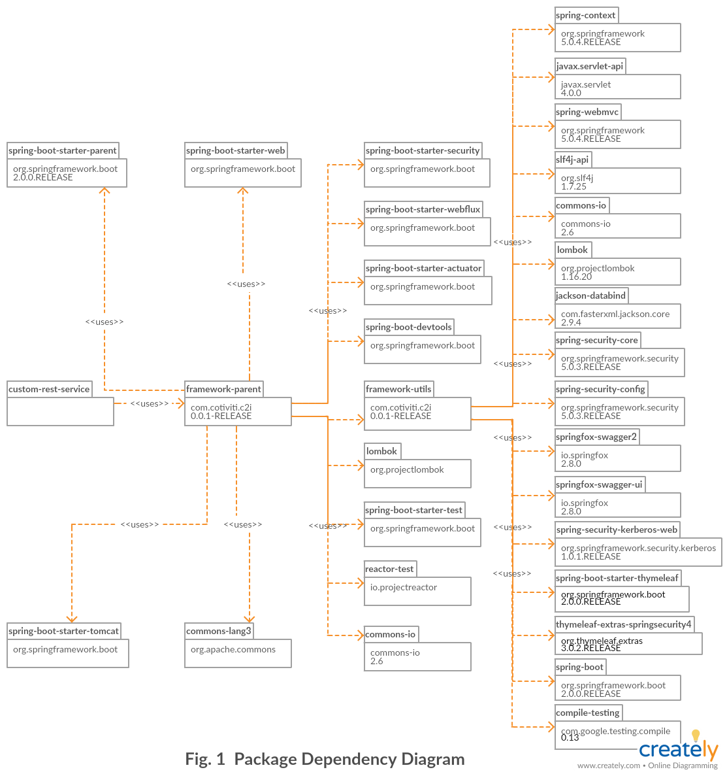

The first iteration of the framework supports Spring Boot applications deployed to stand alone Tomcat application servers. The following picture (Fig. 2) provides the schematic diagram of a Tomcat server with its deployed custom services and their corresponding data sources. As seen from Figure 2, only users inside the Cotiviti internal network will be able to access the web services.

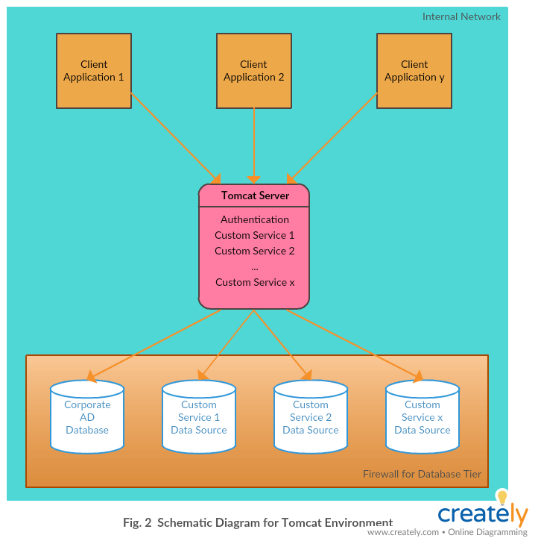
Please refer to the next section to see the data flow for any requests to web services hosted in a Tomcat server.

Security
In this release, the Framework uses Kerberos as the authentication mechanism to validate user requests from client applications to the web services hosted in Tomcat application servers. Spring Security along with Spring Security Kerberos modules are used to satisfy the authentication requirement of this phase. All the Security modules have been included in the framework-utils project and there is no need for developers to directly deal with them. If developers follow the instructions outlined in next chapter correctly, Spring Security will be properly instantiated and be used to secure all web service end points except those that have been specifically opened.
As mentioned earlier, to access the secured web services deployed in a Tomcat application server, users must be valid internal users and have been authenticated with the Cotiviti Corporate AD server. Figure 3 (next page) shows the authentication flow for a user to request a resource from a web service hosted in a Tomcat that is protected by the Kerberos authentication scheme.
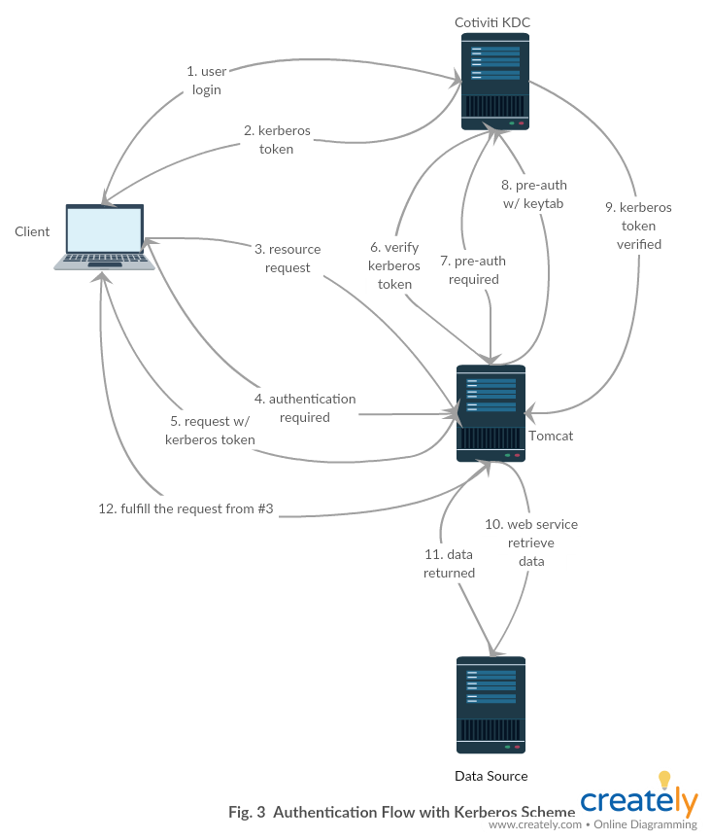

A more detailed sequence diagram of the authentication process is shown in Fig. 4.
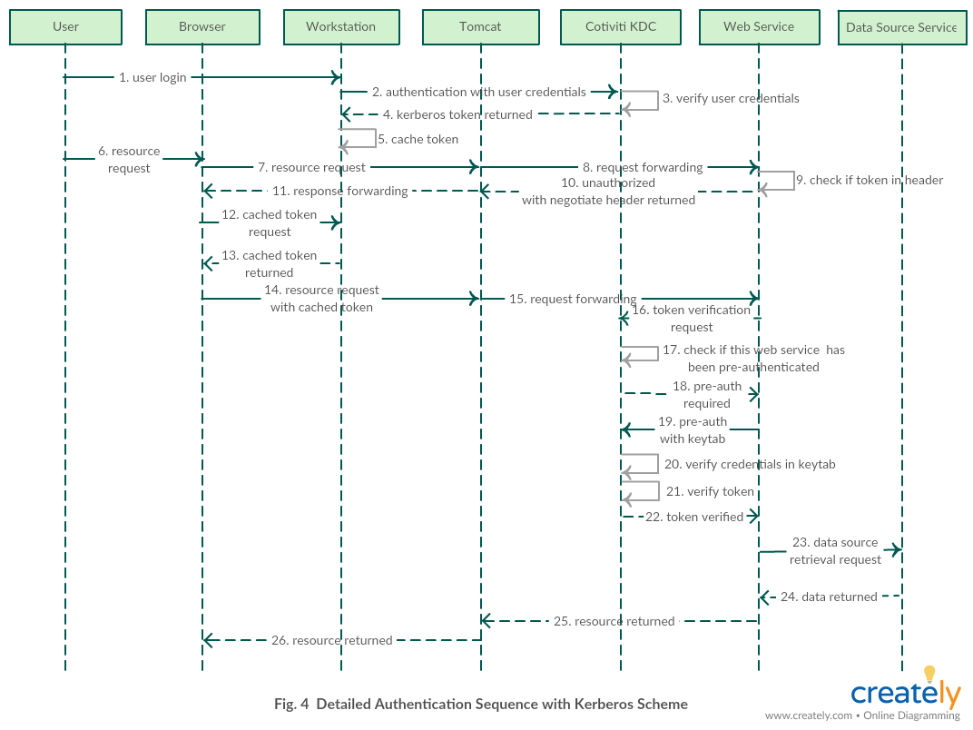
The steps of the sequence in Figure 4 are explained as follows:
- User login – A User first logs in to a Workstation with her/his domain username and password within the Cotiviti internal network
- Authentication with user credentials – The Workstation forwards the User’s credentials to the Cotiviti KDC service
- Verify user credentials – The Cotiviti KDC service verifies the provided credentials with its AD database
- Kerberos token returned – The Cotiviti KDC service returns the Kerberos token to the Workstation if the User’s credentials are matched with the credentials from the AD database
- Cache token – The returned Kerberos token is cached in the Workstation’s local storage
- Resource request – The User opens a Browser to request a resource from a URL provided by a Tomcat application server
- Resource request – The Browser relays the request to Tomcat
- Request Forwarding - Tomcat forwards the request to Web Service
- Check if token in header – Web Service checks if the Kerberos token is in the header
- Unauthorized with negotiate header returned – Web Service returns a 401 Unauthorized error message with negotiate in the www-authenticate header to Tomcat
- Response Forwarding - Tomcat forwards the response from Web Service to Browser
- Cached token request – The Browser requests the cached token from the Workstation
- Cached token returned – The Workstation returns the cached token in step 5 to the Browser
- Resource request with cached token – The Browser resends the resource request with the cached token in the header to Tomcat
- Request forwarding - Tomcat forwards the request to corresponding Web Service
- Token verification request – Web Service extracts the token from the request header and sends it to the Cotiviti KDC service for verification
- Check if Web Service has been pre-authenticated – The Cotiviti KDC service checks if Web Service has been authenticated before
- Pre-auth required – The Cotiviti KDC service returns a pre-authentication required message to Web Service if it has not been pre-authenticated within a timeframe
- Pre-auth with keytab – Web Service retrieves the keytab and sends it to the Cotiviti KDC service for pre-authentication
- Verify credentials in keytab – The Cotiviti KDC service verifies the credentials in keytab
- Verify token – The Cotiviti KDC service verifies the User’s Kerberos token if the credentials in keytab are valid.
- Token verified – The User’s Kerberos token is verified
- Data source retrieval request – The Web Service retrieves data with data source credentials from its associated Data Source Service. The data source credentials are project specific and will not be defined here
- Data returned – The Data Source Service returns the requested data
- Resource returned – The Web Service formats/transforms the data and returns the results to Tomcat
- Resource returned – Tomcat relays the returned results to the Browser for the User to view
In this phase, user authorization is not considered and therefore, all users with valid Cotiviti AD credentials will be able to access the web services.

Versioning
To be compliant with the C2i Web Services Standard, all web service APIs must include the major version in the request path, formatted to match the regular expression “^/v[d+]/(.*)”. To enforce this standard, a Java Annotation has been implemented in the Framework library to validate the correctness of all request paths in all Spring Rest controllers at compile time. Any non-standard request paths in any Rest Controllers will cause the compilation of the associated project to fail.
The C2iApiFormat annotation interface outlined above is defined in the com.cotiviti.c2i.utils.annotations package of the framework-utils project. Its processor class is named C2iApiFormatProcessor and it is located in the com.cotiviti.c2i.utils.processors package. For now, it only applies at the class (ElementType.TYPE) level.

JSON Request & Response
As specified in the C2i Web Services Standard, all custom web services will support JSON only requests and responses. To support this requirement, the Services Framework has added validation functions to the C2iApiFormatProcessor class to make sure API methods will only handle JSON requests. The validation is performed at compile time just like the enforcement of the API versioning. This will require the client to send requests with the header “content-type=application/json”. If this header is missing from the request, an “Unsupported Media Type” error message along with a 415 HTTP status code will be returned.
To validate the JSON only API response, the C2iRestController Java annotation was added to the library. It is “inherited” from the Spring Framework @RestController annotation to ask the Spring Framework to use the JSON response handler to create JSON responses. To provide documentation to developers that create applications to consume the web services, the Services Framework also provides enforcement in the C2iApiFormatProcessor class to make sure the API developers define that the API responses of the web services are in JSON format only. If the configuration for exposing this information is missing, the compilation of the web service project will also fail.

API Documentation
The API document is an essential feature of modern web services. It provides detailed information about a web service and therefore makes it easy for client-side applications to consume it. This Services Framework has integrated with Swagger UI to help web service developers generate API documents automatically. The integration is implemented in the C2iConfig class under the com.cotiviti.c2i.utils.configs package.
Once the web service main application class imports the C2iConfig class and the package name of the rest controller class is placed in the application.yml file under the key of webService.swaggerBasePackage, the API document will be generated and can be accessed via http://base-url:port-number/context-path/swagger-ui.html, where base-url is the FDQN, port-number is the port number of the web service, and context-path is defined under the server.servlet.context-path key of application.yml file.

Custom Web Service Creation
The C2i Services Framework has provided a sample project, hello-cotiviti, that demonstrates how to use the Framework to create web services compliant with the standard defined in the Digital Web Services Standard. The following sections will provide step-by-step instructions to create custom web services. However, it would be best for custom web service developers to get the sample project and go through the project structure and the code first.

Prerequisites
To develop web services based on the C2i Services Framework, the developers’ workstations will need:
- Maven 3.2+
- Eclipse Oxygen or Spring Tool Suite 3.9.1 with the m2e plugin
- JDK 1.8.0_101 or later
- Tomcat 8.0.36

Maven POM
Apache Maven has been chosen as the build and dependency management tool to develop custom web services based on the C2i Services Framework. As described in Section 3, a Maven parent POM that contains all necessary libraries for creating custom web services has been constructed to allow custom web service developers to create web services with concentration on business logic rather than worrying about the plumbing underneath.
To start a web service project, developers just need to create a Maven project with the “Create a simple project (skip archetype selection)” option. Then, edit the pom.xml to insert the following xml snippet under the root (project) node,
<parent>
<groupId>com.cotiviti.c2i</groupId>
<artifactId>framework-parent</artifactId>
<version>0.0.1-RELEASE</version>
<relativePath></relativePath>
</parent>
Make sure that you are set up to build with Java 8 by adding the following properties:
<properties>
<project.build.sourceEncoding>UTF-8</project.build.sourceEncoding>
<java.version>1.8</java.version>
<maven.compiler.source>1.8</maven.compiler.source>
<maven.compiler.target>1.8</maven.compiler.target>
</properties>

Since we do not yet have a central repository to store binary artifacts, we must install the framework-utils artifact first and then the parent POM. To install them, developers will need to clone the https://github.com/cotiviti/PlatformServices.git repo, go to the PlatformServices/framework-utils directory, and issue the following Maven command to build the project:
mvn clean install

This will generate the library jar file and install it to the local repository. The next step is to switch to the PlatformServices/framework-parent directory and issue the same Maven build command. This will also install the POM into the local repository for later use in developing the custom web services. Now, the custom Maven project should compile without any errors. Of course, there is no code yet! We’ll add some in the next section.

Main Application Implementation
The main application class is implemented to instantiate all required Spring beans and to start the web service with embedded Tomcat or to bind the servlet, filters, and beans from the application context to a stand-alone Tomcat server.
To implement the main application class, simply use the following code (replacing the class name with the preferred name):

@SpringBootApplication // providing opinionated default configuration attributes
@Import(C2iConfig.class) // importing all necessary beans to enforce standard
public class C2iApplication extends SpringBootServletInitializer {

@Override
protected SpringApplicationBuilder configure(SpringApplicationBuilder application) {
return application.sources(C2iApplication.class);
}

public static void main(String[] args) {
SpringApplication.run(C2iApplication.class, args);
}
}

SpringBootServletInitializer is used here to allow the Spring Boot application to be deployed to a servlet container, such as a Tomcat application server.
Now that you have defined the main application class, add it to the pom.xml in the <properties> section like this:
<start-class>com.cotiviti.c2i.sample.C2iApplication</start-class>

Rest Controller Implementation
With the Spring Framework, a class annotated with @RestController implements a rest service. @C2iRestController extends @RestController to add security configuration to the application. So, instead of using @RestController to annotate a web service class, @C2iRestController will be used to annotate it. Also, the @C2iApiFormat annotation will need to be used at the class level to enforce the versioning scheme and Messaging format defined in the standard. The last required item is to annotate all service end points with @RequestMapping and make sure its value, consumes, and produces attributes are defined correctly according to the standard. The code snippet below provides an example of a web service implementation:

@C2iRestController
@C2iApiFormat
public class CustomerController {

@RequestMapping(method = RequestMethod.GET, value = {"/v1/customers/{id}", "/v2/customers/{id}"}, consumes="application/json", produces="application/json")
public Customer findById(@PathVariable final long id) {

Faker faker = new Faker();
return new Customer(Long.parseLong(randomNumeric(9)), faker.name().fullName(), randomNumeric(12));
}
}
The consumes and produces attributes must be set to “application/json”, and the format of value needs to match the regular expression “^/v[d+]/(.*)”.

Application Properties
Application properties should be defined in YAML format. Use the application.yml file in the src/main/resources directory of the hello-cotiviti project as a starting point.
The following properties are required:

info:
app:
name: "@project.artifactId@"
description: "@project.description@"
version: "@project.version@"

spring:
application:
name: "@project.artifactId@"
jackson:
default-property-inclusion: NON_NULL

The standard for C2i services is to leave properties that are null out of the response. However, you can remove this property if your requirements are to send all properties regardless of whether they are null or not.
In general, the next properties should not need to be changed for custom web service projects with the current deployment strategy (using stand-alone Tomcat as the application container). The server.port and server.servlet.context-path will be ignored by Tomcat.

server:
port: 8081
servlet:
context-path: /hello

The following properties may be useful if you are debugging an issue:
logging:
level:
org:
springframework:
security: DEBUG
web:
servlet: DEBUG
com:
cotiviti:
c2i: DEBUG
The next set of properties sets up the Swagger API documentation and security. These properties will be covered in a future section once integration with Kerberos is finalized.

webService:
swaggerBasePackage: com.cotiviti.c2i
service-principal: HTTP/c2iwebservices@COTIVITI.COM
keytab-location: /tmp/webservice.keytab
ignored-security: /error,/v2/api-docs,/configuration/ui,/swagger-resources,/configuration/security,/swagger-ui.html,/webjars/**,/actuator/*

The service-principal and keytab-location properties are required. The service-principal will need to be changed according to your service account name. The keytab-location should point to the keytab file name and location on your server.

By default, the base framework will use com.cotiviti.c2i as the base package for Swagger to scan and create API documents. If your custom service project uses com.cotiviti.c2i as the prefix package name, there is no need to specify the webService.swaggerBasePackage option; otherwise, you can specify it as above. If all the service end points are required to be secured, then the default setting as above in webService.ignore-security is enough. However, if there is a particular end-point that needs to be opened for everyone to access, it will need to be specified in this key. For example, appending “/v2/customers/*” to the existing value of the ignore-security key would open the v2/customers end-point, as shown below:

ignored-security: /error,/v2/api-docs,/configuration/ui,/swagger-resources,/configuration/security,/swagger-ui.html,/webjars/**,/actuator/*,/v2/customers/*

The corsFilters properties set up the values for headers on the response. The format of these properties is subject to change in future versions.

corsFilter:
headers:
allow-origin: "*"
allow-methods: "POST, PUT, GET, OPTIONS, DELETE"
allow-headers: "Authorization, Content-Type"
max-age: 3600

Unit Tests
Unit tests must be created for all service end points of a web service with all the boundary conditions covered. Annotate your test class with the JUnit annotation @RunWith(SpringRunner.class) and the Spring annotation @SpringBootTest(webEnvironment = WebEnvironment.RANDOM_PORT).

See the sample project for an example test.

If you want to run unit tests without security in place, it will be helpful to set up a separate testing profile that bypasses security. You can do this with the following entries in the application.yml:
spring:
profiles: test

webService:
ignored-security: /**

Then, either
- annotate your test class with @ActiveProfiles(value = "test") [OR]
- run with the Maven command
mvn install --spring.profiles.active=test

Build Process
Follow the build sequence listed below due to the dependency requirements among the different projects:
- Build framework-utils project: mvn clean install
- Build framework-parent project: mvn install
- Build custom project (hello-cotiviti): mvn clean install

Deployment

Stand Alone Tomcat
Please refer to the Digital Web Services Deployment document for deploying custom web services to a stand-alone Tomcat instance.

Embedded Tomcat
To run applications with embedded Tomcat and with DevTool support, use the command
mvn spring-boot:run

DevTool will restart the application automatically if any source code has been modified.

To run applications with embedded Tomcat in a production environment, use the command
java –jar custom-web-service.jar --server.port=8800
--server.servlet.context-path=/hello

You can access various end points from an instance started with the second command above from a browser:
- For the info end point, use http://localhost:8800/hello/actuator/info
- For the health end point, use http://localhost:8800/hello/actuator/health
- For the API document of the service, use http://localhost:8800/hello/swagger-ui.html
- For other business logic end points, use http://localhost:8800/hello/[value-attribute-defined-in-RequestMapping-annotation].

Troubleshooting
To be filled-in in the future as and when we learn more about the issues and their fix.

References

S.No. | Document Title | Version | Author | Location

